**API Tests**

**Findings/Bugs**

**General:**

1 - Header "correlation-id" has inconsistence behavior: in some requests it is returned but in others it is not (regardless of the status code of the request)

2 – Header “device-os” allows different value than the applicable ones (ios/android)

Example request: Test Collection\Login UK\Invalid\Login UK - Invalid device-os

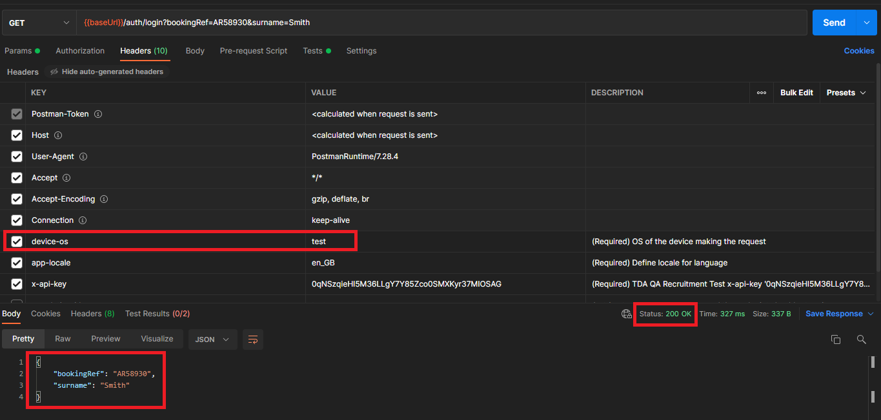

**Auth endpoints**

**Login UK:**

1 – Invalid “app-locale” shows error 401 in response instead of 400 (Bad request

Example request: Test Collection\Login UK\Invalid\Login UK - Invalid app-locale

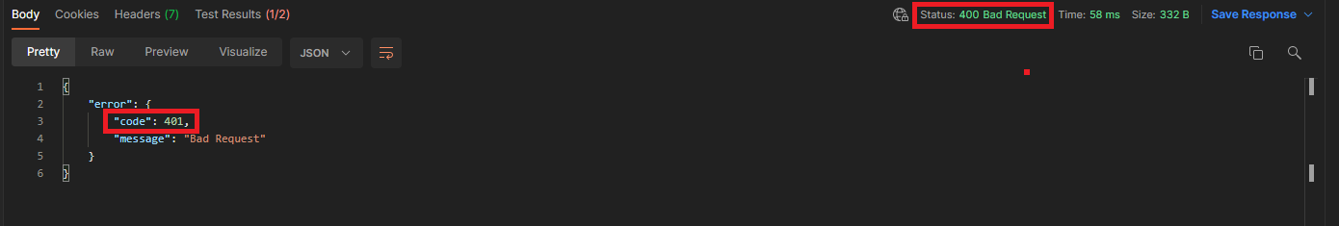

**Healthcheck:**

When header app-locale = en_GB

1 - Response has a typo: "stetus" instead of "status"

2 - Missing "apiVersion" on the response (available for app-locale = de_DE)

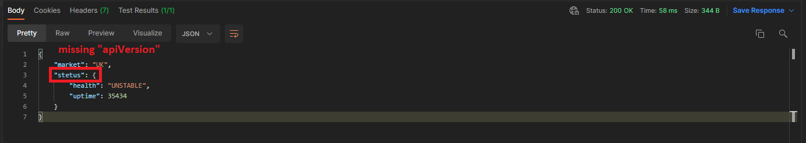

When header app-locale = de_DE

3 - "uptime" has null value

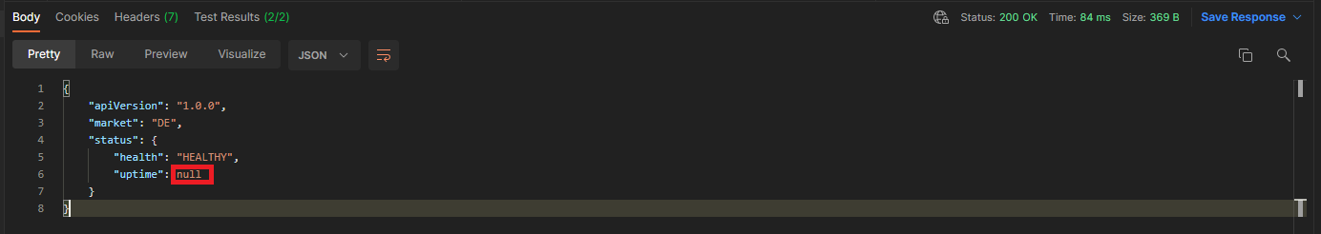

**Booking:**

/v1/bookings/{id}

1 – “status” property displays value “pre” but the property is restricted to values: PRE, ON and POST

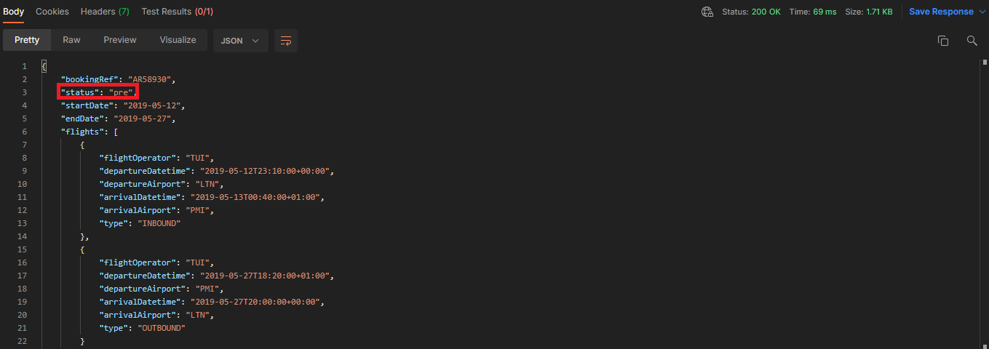

2 – Although is not a structural bug of the response, the property “country” assumes values like “Mallorca”, which does not seem right in terms of the concept.

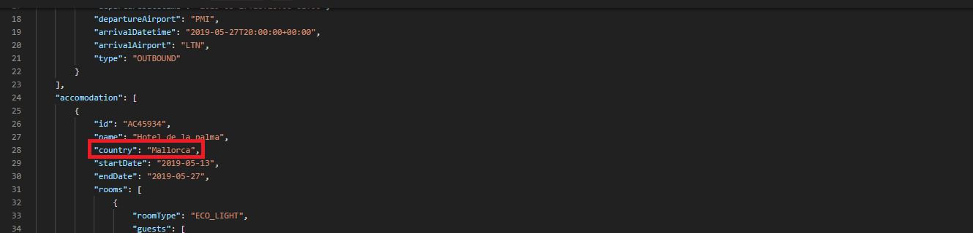

3 – According to the response model, the list of “guests” should have at least one guest with sub-property ”lead”: true.

